Ai Stylist

**1. Methodology process**

**AI Stylist follows the Agile Scrum methodology as shown in the figure1 to ensure continuous improvement and adaptability. Development is structured into sprints, focusing on refining AI models, enhancing the user experience, and integrating new fashion trends. Regular feedback loops ensure accurate, personalized recommendations. This approach enables rapid updates, reducing time- to-market and enhancing user satisfaction**

# Planning Phase

* 1. Define the AI Stylist as a personalized fashion recommendation platform
  2. Identify key stakeholders including fashion industry experts and target users
  3. Focus requirements on core features: body type analysis, style preference collection, and AI-driven outfit recommendations
  4. Prioritize user experience and fashion accuracy as top non-functional requirements

# Design Phase

* 1. Create a visually appealing UI with the purple color scheme shown in mockups
  2. Design three main interfaces: Home, Personal Analysis, and Recommendations
  3. Develop AI algorithms specifically for analyzing body shapes and matching with appropriate clothing styles
  4. Plan for integration with fashion retailers' inventory APIs

# Development Phase

* 1. Build the photo upload functionality for body measurement analysis
  2. Implement the style preference questionnaire (clothing style, color preferences, measurements)
  3. Develop the recommendation engine to create curated outfit collections (Casual Work, Formal Event, Athletic)
  4. Create filtering system by occasion, price, color, and season

# Testing Phase

* 1. Test body measurement analysis accuracy across diverse body types
  2. Validate style recommendations against fashion best practices
  3. Ensure recommendations appropriately match user preferences
  4. Verify filter functionality for different outfit collections

# Deployment Phase

* 1. Launch marketing campaign highlighting AI-powered personalization
  2. Implement phased rollout starting with core body types and common styles
  3. Establish fashion data pipeline for keeping recommendations current
  4. Deploy with focus on mobile responsiveness for on-the-go style advice

# Maintenance and Support Phase

* 1. Track which recommendations receive positive user feedback
  2. Update the system with seasonal fashion trends
  3. Expand the clothing database with new styles and brands
  4. Refine body analysis algorithms based on user feedback

# Timeline

* 1. Initial launch with core body types and basic style recommendations
  2. Second phase adding detailed measurements and expanded style options
  3. Third phase introducing smart shopping features across multiple retailers

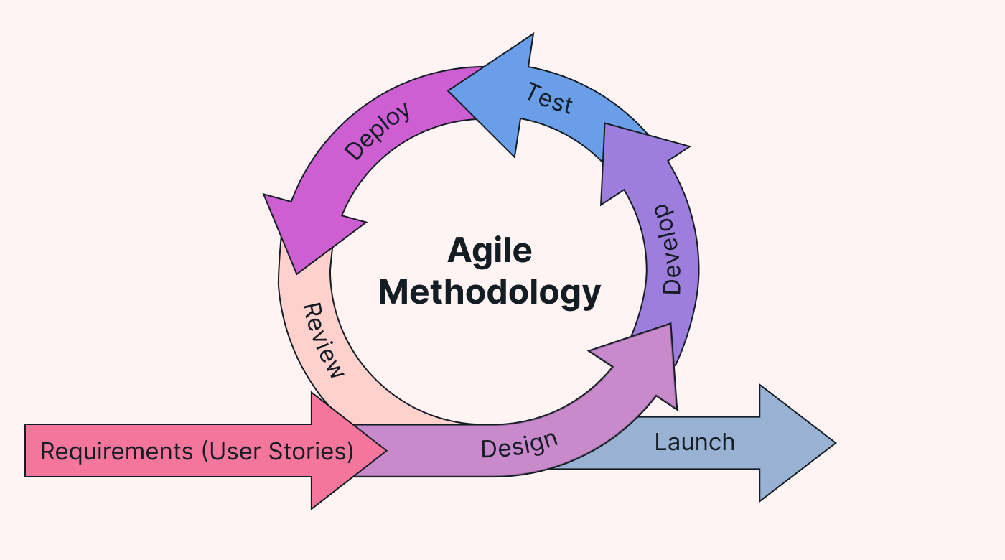

Figure1 Agile Methodology (https://cssanimation.io/blog/unleashing-the-power-of-scrum-how-agile-methodology-is-revolutionizing-business/, n.d.; https://www.usemotion.com/blog/agile-methodology, n.d.)